Alpha Quant Notes
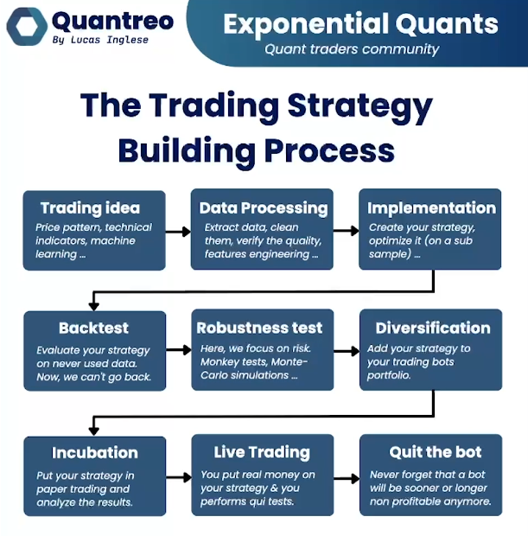

Setting up the Anaconda Environment:
- Virtual environments are important in python, they allow you to set a specific environment for your project, that uses specific versions of python and python’s libraries. This is vital because if the wrong versions are used, it might break the project, making some files impossible to run. If the project is built by someone else, you always want to make sure you have the exact same environment that they used to build it. This is generally done by a requirements.txt file, which simply lists every library and version of said library needed to use the codebase. Without going into too much detail since more instructions are on the github’s readme, you need to download anaconda, make a new environment in anaconda navigator (call the new env “AlphaQuant” if you to want to keep it consistent with the existing code, otherwise you may need to make some small changes for a different name), use the requirements file to configure the environment correctly, and (optional but useful), change your setting in VScode or Cursor so that the environment automatically loads whenever you open the project. If needed, a LLM like Claude can easily help you go through this process.

Importing Data:
- Import tick data or rates (candle) data from MT5 using notebook guides or create_databases.py
  - Be aware only 99,999 rows of data can be fetched in one call using create_databases.py, however, you can do multiple calls, create multiple csv files, then combine them to get more data in a longer timeframe
- Use HighLowTime.py to preprocess a longer time frame database (such as 1 hour), using a shorter time frame (such as 5 min) to identify what specific time during the 1 hour candle the high and low appear.
  - Ex: you enter a trade at 505, your TP is 525, your SL is 500. A 1 hour candle shows a bottom wick of 498 and a top wick of 532. Without identifying the time the high/low appear, your backtesting algo won’t know whether the SL or TP was hit first during that 1 hour candle. If we identify the high at 1:05 and the low at 1:35, we then know that the 532 price was reached before the 498 price, and thus, the TP was hit first and it’s correctly logged as a winning trade.

Data Preprocessing:
- Once data is imported, and high/low times added, we need to add features based on the strategy we want to use
  - Ex: if you want to use a strategy based on SMA and RSI, need to add new columns to the data representing the SMA and RSI features, basically, SMA is at 102.34 at 1:05, RSI is at 58 at 1:05, etc.
- Use the Quantreo/DataPreprocessing.py file to add in more features, notice the usage of a python library that makes adding new features trivial
- Relevant libraries (allows easy addition of features):
  - TA, TA-lib, Oryon
    - TA and TA-lib have many functions for common indicators like RSI/Mas and other stuff, check out the documentation to see what options are available (notice TA is different from TA-lib)
- Oryon:
  - Lucas Inglese Rust-core, Python-API library for production-grade feature and target engineering. Key advantage: same pipeline object works identically in backtesting and live trading - no code duplication.
  - Features (backward-looking, safe for live streaming):
    - Trend:
      - SMA, EMA, KAMA (adaptive), LinearSlope (slope + $R^{2}$)
    - Volatility:
      - Parkinson (H/L only, range-bound markets), Rogers-Satchell (OHLC, trending markets)
    - Returns:
      - SimpleReturn, LogReturn (additive, preferred for ML)
    - Statistics:
      - ADF (stationarity/regime detection), Skewness, Kurtosis, MedianMA (outlier-robust smoother), ShannonEntropy (regime filter), Correlation (Pearson/Spearman/Kendall), AutoCorrelation
    - Scalers:
      - RollingZScore — adaptive, use during research
      - FixedZScore — fit on train set only, use in production
    - Targets (forward-looking, research only):
      - FutureReturn — standard return prediction label
      - FutureLinearSlope — slope + $R^{2}$of future price (richer than return alone)
      - FutureCTCVolatility — realized vol label for vol forecasting models
    - Key design details worth noting:
      - Every feature has a reset() method — call between CPCV/WFO folds to prevent state leakage across splits
      - NaN propagation is explicit and consistent across all features
      - ADF + ShannonEntropy are particularly useful as regime filters before applying directional signal

Trading Strategies:
- Get your features loaded in the data
- Create buy and sell conditions
  - Ex: signal = 1 if all buy conditions are met, signal = -1 if all sell conditions are met, signal = 0 otherwise
- Create entry/exit signal
  - Notice that in …RsiSMA.py, signals are created using the -2 instead of the -1 index. Basically using the timestamp right before the current timestamp to create the signal. If you use the current timestamp, then indicators like SMA and RSI are calculated using the current timestamp’s open and close prices. But since it’s the current timestamp, the close price won’t be known yet in live trading. The indicators are created using data from the future, which is called “look-ahead bias”. This makes strategies look more profitable than they actually are in backtesting, since, of course it’ll be easier to make money if we know where the price will be in the future, but we won’t know that in live trading, so the integrity of the strategy is compromised. Always avoid look-ahead bias!
  - Notice entry_signal is different from signal, signal only shows if all conditions are met for a buy/sell. entry_signal shows if we’re actually able to enter (we can only enter a position if we’re not already in a position, at least at this point)
  - exit_signal is created in a similar way

